BDD Spec Flow
BDD bridges the gap between QA/BA/Developer/Stake holder

There are many tools available to support BDD , some most famous tools are
Cucumber – many languages
Jbehave – Java , NBehave C#
SpecFlow C#

But all the above tools have on language in common which is Gherkin

Gherkin is the format for Cucumber specification
It is a business readable , Domain specific language which will let anybody to understand the software behavior easily
Gherkin has some spaces and indentation to define structure
Gherkin has very few syntax which make the parser
The Syntax of Gherkin are very simple and are pretty readable as plain text

Gherkin Syntax
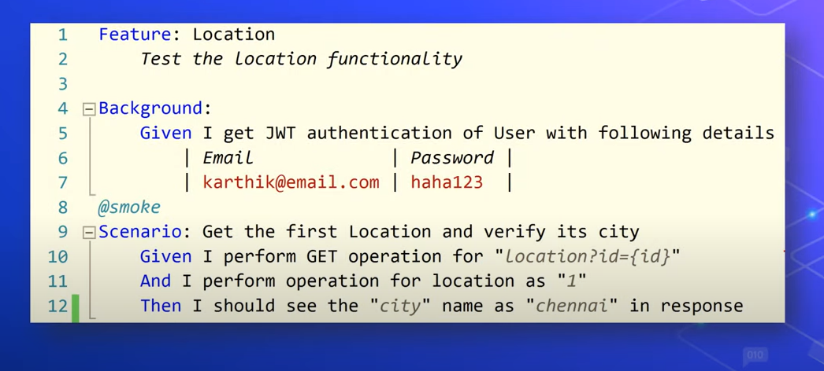

Specflow also support .NET 2.0 standard , which mean , it supports .NET Core 3.1 out of box

Test Project is NUnit Test Project (.NET Core)

SpecFlow for VS 2019 – install the extension for VS
NUnit 3 Test Adapter – another extension

Create two folder
Feature – contains spec flow feature file
Stepes -

Nuget Package – SpecFlow , SpecFlow.NUnit , SpecFlow.Tools.MsBuild.Generation , SpecFlow.Assist.Dynamic (useful when working with specflow tables)
Selenium.WebDriver,Selenium.Chrome.WebDriver
Login.Feature.cs file

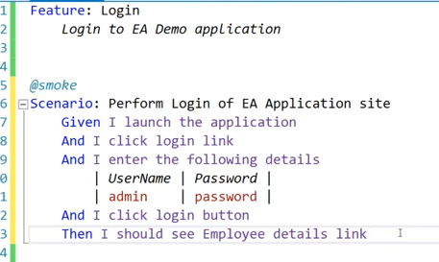

Right click on SpecFlowFeature and click on Generate code or you can copy the code and paste it in the step definition cs file

Selenium Page object model code

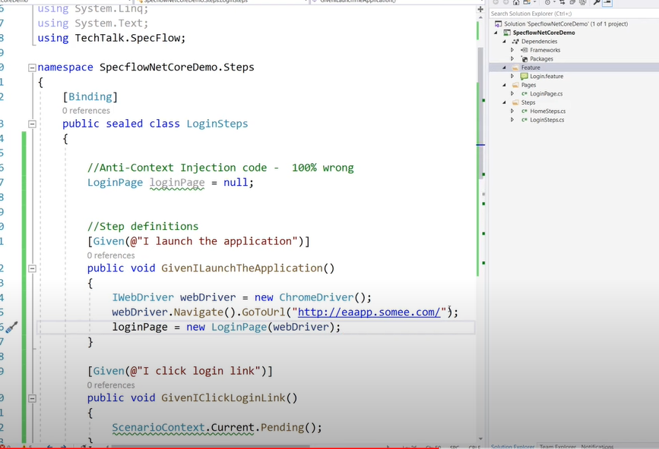

Specflow for .Net Web API

